Odaa
· · ·
Community Fund Management System
A multi-tenant SaaS platform for HOA / residential-community financial administration
Project Documentation

Table of Contents
1. Overview 4
1.1 What Odaa Is 4
1.2 Problem It Solves 4
1.3 How Odaa Addresses This 4
1.4 Primary User Roles 4
1.5 Document Scope 5
2. System Architecture 5
2.1 Technology Stack 5
2.2 High-Level Architecture 5
2.3 Multi-Tenancy Model 6
2.4 Request Lifecycle 6
3. Data Model 6
3.1 Entity Overview 6
3.2 Entity-Relationship Diagram 8
3.3 Notable Modeling Decisions 8
Payment target is XOR, not polymorphic 8
Expense correction is append-only, not editable 9
Phone login uses a precomputed search key 9
Fund category is now its own column 9
A project can be jointly funded across more than one Fund 9
Money is always Decimal, never Float 9
Residents are deactivated, never deleted 9
4. Authentication & Authorization 9
4.1 Authentication Flow 9
4.2 Sequence: Login → Refresh 10
4.3 Authorization Model 11
5. Core Domain Workflows 11
5.1 Bank Payment Self-Verification 11
5.2 Append-Only Expense Ledger 11
5.3 Multi-Party Approval Workflows 12
Committee seat transfer 12
Generalized sensitive-change approval (PendingChange) 12
5.4 Audit Log 12
5.5 Committee Auto-Approval 12
6. API Reference 12
6.0 Conventions 12
6.1 Auth 12
6.2 Communities 13
6.3 Residents 13
6.4 Fees 13
6.5 Payments 13
6.6 Funds 14
6.7 Projects 14
6.8 Expenses & Receipts 15
6.9 Committee Transfers 15
6.10 Pending Changes 15
6.11 Dashboard & Reports 16
6.12 Audit Log 16
6.13 Committee Auto-Approval 16
7. Known Limitations & Design Tradeoffs 16
8. Deployment 16
8.1 Database Migrations & Seeding 16
8.2 Environment Variables 16
8.3 Health Checks & Observability 17
9. Frontend Structure 17
10. Testing 17
11. Security 17
12. Product Vision & Multi-Tenant Roadmap 17
12.1 Vision Summary 17
12.2 Onboarding & Tenant Provisioning 17
12.3 Open Decision: Tenant URL Scheme 19
12.4 Planned Feature Modules 19
12.4.1 Voting System 19
12.4.2 Messaging 19
12.4.3 Bulk Member Import 19
12.4.4 Native App Version 19
12.4.5 Recurring Fee Automation & Late-Fee Rules 20
12.4.6 Meeting Scheduling & Minutes 20
12.4.7 Two-Factor Authentication for Admin Actions 20
12.5 Architectural Implications 20
12.6 Status 21
List of Figures
Figure 1: High-Level System Architecture 5
Figure 2: Entity-Relationship Diagram 8
Figure 3: Sequence Diagram — Login and Refresh-Token Rotation Flow 10
Figure 4: Tenant Onboarding & Provisioning Flow 18

1. Overview

— 1.1 What Odaa Is
Odaa (formerly referred to internally as CFMS — Community Fund Management System — during early development; the project has since settled on the name Odaa) is currently built and documented around one use case: a multi-tenant SaaS application that lets residential communities — homeowner associations, apartment/condo committees, or similar self-governing residential groups — manage dues collection, shared funds, capital projects, expenses, and committee governance in one place. Each community (a "tenant") self-registers on the platform, gets its own isolated data space, and is run day-to-day by an elected/appointed committee (ADMIN users) on behalf of its residents. The underlying model isn't specific to residential communities, though — it's a general engine for membership dues, shared funds, and approval-based governance that could just as easily serve companies, clubs, or other member-based organizations. Section 9 lays out that broader, multi-tenant direction in more detail.

— 1.2 Problem It Solves
Community-run funds are typically managed today with a mix of physical cash boxes, WhatsApp groups, and personal spreadsheets. This creates three recurring failure modes that Odaa is designed around:
- No verifiable trail of who paid what, when, and whether it was actually deposited — payment status is whatever the treasurer remembers or wrote down.
- Bank transfer payments are typically self-reported by residents ("I sent it, trust me") with no independent verification, or require a manual bank-statement cross-check that doesn't scale past a handful of residents.
- Single points of failure and trust: one committee member can unilaterally change sensitive records (bank account details, fee amounts) or hand off their seat with no oversight from the rest of the committee.

— 1.3 How Odaa Addresses This
- A single append-only Payment/Expense ledger per community, with role-scoped visibility for residents and committee members.
- Resident self-service bank-payment verification: a resident submits a transaction ID and Odaa cross-checks it against the actual bank/mobile-money provider (see §5.1) instead of trusting a typed-in claim.
- A generalized multi-party approval workflow (PendingChange) for sensitive edits, and a dedicated approval flow for handing off a committee seat, so no single committee member can act alone on high-stakes changes.
- A permanent, non-editable audit log of every meaningful action taken in a community, visible to every committee member.

— 1.4 Primary User Roles
Role | Scope | Represents
ADMIN | One community | A committee member of that community. Manages residents, fees, funds, projects, expenses, and reviews sensitive-change proposals.
RESIDENT | One community, own records | A resident/unit owner or renter. Pays fees, views their own payment history, and reviews their own outstanding balance.

— 1.5 Document Scope
This document covers the system as implemented at the time of writing: architecture, data model, authentication, core domain workflows, the full REST API surface, and known design tradeoffs. It is written for engineers reviewing or extending the codebase, and is intended to be read alongside the source, not as a replacement for it.

2. System Architecture

— 2.1 Technology Stack
Each layer was picked for being boring and well-understood rather than novel, since the system's job is to be a trustworthy financial record, not a technology showcase. Express + Prisma + PostgreSQL is a conventional, heavily-documented combination with a large hiring/support surface; React + Vite + Tailwind is the same story on the frontend. The one deliberately "newer" dependency is Zod for validation, chosen because it lets a request shape be defined once and get both runtime validation and (implicitly) documentation of what a valid payload looks like, instead of the two drifting apart over time.
Layer | Technology
Frontend | React 18 + Vite, Tailwind CSS, React Router, Recharts (dashboards), jsPDF / xlsx (exports), lucide-react (icons), axios (HTTP client)
Backend | Node.js, Express 5, Prisma ORM, Zod (request validation), JWT (jsonwebtoken), bcryptjs, Helmet, express-rate-limit, Multer (uploads)
Database | PostgreSQL 16
External services | Veritas — an unofficial third-party API that verifies Ethiopian bank/mobile-money transactions (CBE, Telebirr, Dashen, Bank of Abyssinia, CBE Birr, M-Pesa); OCR.space — third-party OCR API used to extract text from uploaded receipts/payment screenshots
Deployment | Docker Compose (Postgres + backend + frontend containers); backend deployable to any Node host, frontend built as a static bundle

— 2.2 High-Level Architecture
Odaa is a conventional three-tier web application: a React SPA talks to a stateless Express REST API over HTTPS, which is the sole owner of the PostgreSQL database. There is no server-side rendering and no direct database access from the client.
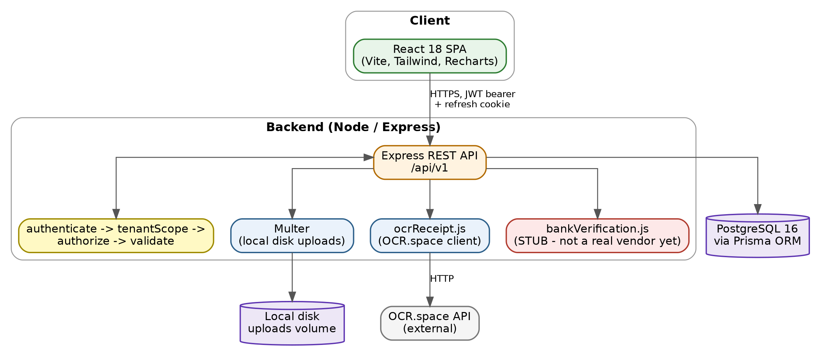
Figure 1: High-Level System Architecture — client, backend middleware chain, and database

— 2.3 Multi-Tenancy Model
Odaa is multi-tenant at the application layer, not the infrastructure layer: all communities share one database, one schema, and one running instance of the API. Isolation is enforced in code, not by separate databases or schemas per tenant.
- Community is the tenant root. Every tenant-scoped table (Resident, Fee, Payment, Fund, Project, Expense, AuditLog, etc.) carries a communityId, directly or via a relation.
- A single middleware, tenantScope, runs on every authenticated route and derives req.communityId from the logged-in user's own community — never from a client-supplied value — then every controller query filters on it.
NOTE This is an application-layer isolation model, not a database-level one (e.g. Postgres Row-Level Security or per-tenant schemas). It is correct as long as every query goes through tenantScope and no controller trusts a client-supplied communityId — a real gap to be aware of when extending this code, since a missed filter is a cross-tenant data leak, not just a bug.

— 2.4 Request Lifecycle
- Helmet (security headers) → CORS → JSON/urlencoded body parsing → cookie parsing → request logging (morgan) → rate limiting (300–1500 req/15min depending on environment; auth endpoints have a separate, stricter 20 req/15min limiter).
- authenticate — verifies the JWT access token and attaches req.user.
- tenantScope — resolves req.communityId as described above.
- authorize(...roles) — per-route allow-list of roles.
- validate(schema) — Zod schema validation of params/body before the controller runs; failures return 422 with field-level errors.
- Controller → Prisma → PostgreSQL.

3. Data Model
The schema is defined in Prisma (prisma/schema.prisma) and is the single source of truth for the database. Key entities and relationships:

— 3.1 Entity Overview
Entity | Purpose
Community | Tenant root. Holds the community's identity and its bank-payment receiving details used for self-verified payments.
User | Login identity (email + password hash) with a role. communityId is nullable pending assignment.
Resident | One-to-one extension of a RESIDENT User with unit, contact, and occupancy details.
Fee | A recurring or one-time charge a community levies on residents (e.g. monthly dues).
Payment | A resident's payment against exactly one of a Fee, a Project, or a Fund directly.
Fund | A named pool of money (e.g. "Emergency Fund") a community maintains.
Project | A capital project funded from a specific Fund, with its own budget.
Expense | Money spent against a Project (or unattached), recorded by a committee member. Append-only — see §5.2.
Receipt | An uploaded proof-of-purchase file attached to an Expense.
AuditLog | Immutable record of every meaningful action taken in a community.
CommitteeTransferRequest / Approval | Multi-party workflow for one committee member handing their seat to a resident.
PendingChange / Approval | Generalized multi-party approval workflow for sensitive edits to any entity type.
RefreshToken | Server-side record of issued refresh tokens, enabling rotation and revocation.
PasswordResetToken | Single-use, short-lived, hash-only token for the forgot-password flow (see §4.1). Mirrors RefreshToken's pattern so a database dump alone can never be used to reset a password.
CommunityBankAccountHistory | Snapshot of a community's payment bank account every time it changes. Lets a payment sent to a since-replaced (but valid-at-the-time) account still verify correctly instead of being flagged as a mismatch.
ProjectFundAllocation | Breaks a Project's budget down across more than one Fund, when a capital project is jointly funded. The allocation amounts must sum to the project's budget.
CommitteeAutoApproval | A committee member's standing pre-authorization to auto-approve future PendingChanges of a given changeType, optionally scoped to specific co-admins, always with a mandatory expiry (see §5.5).

— 3.2 Entity-Relationship Diagram
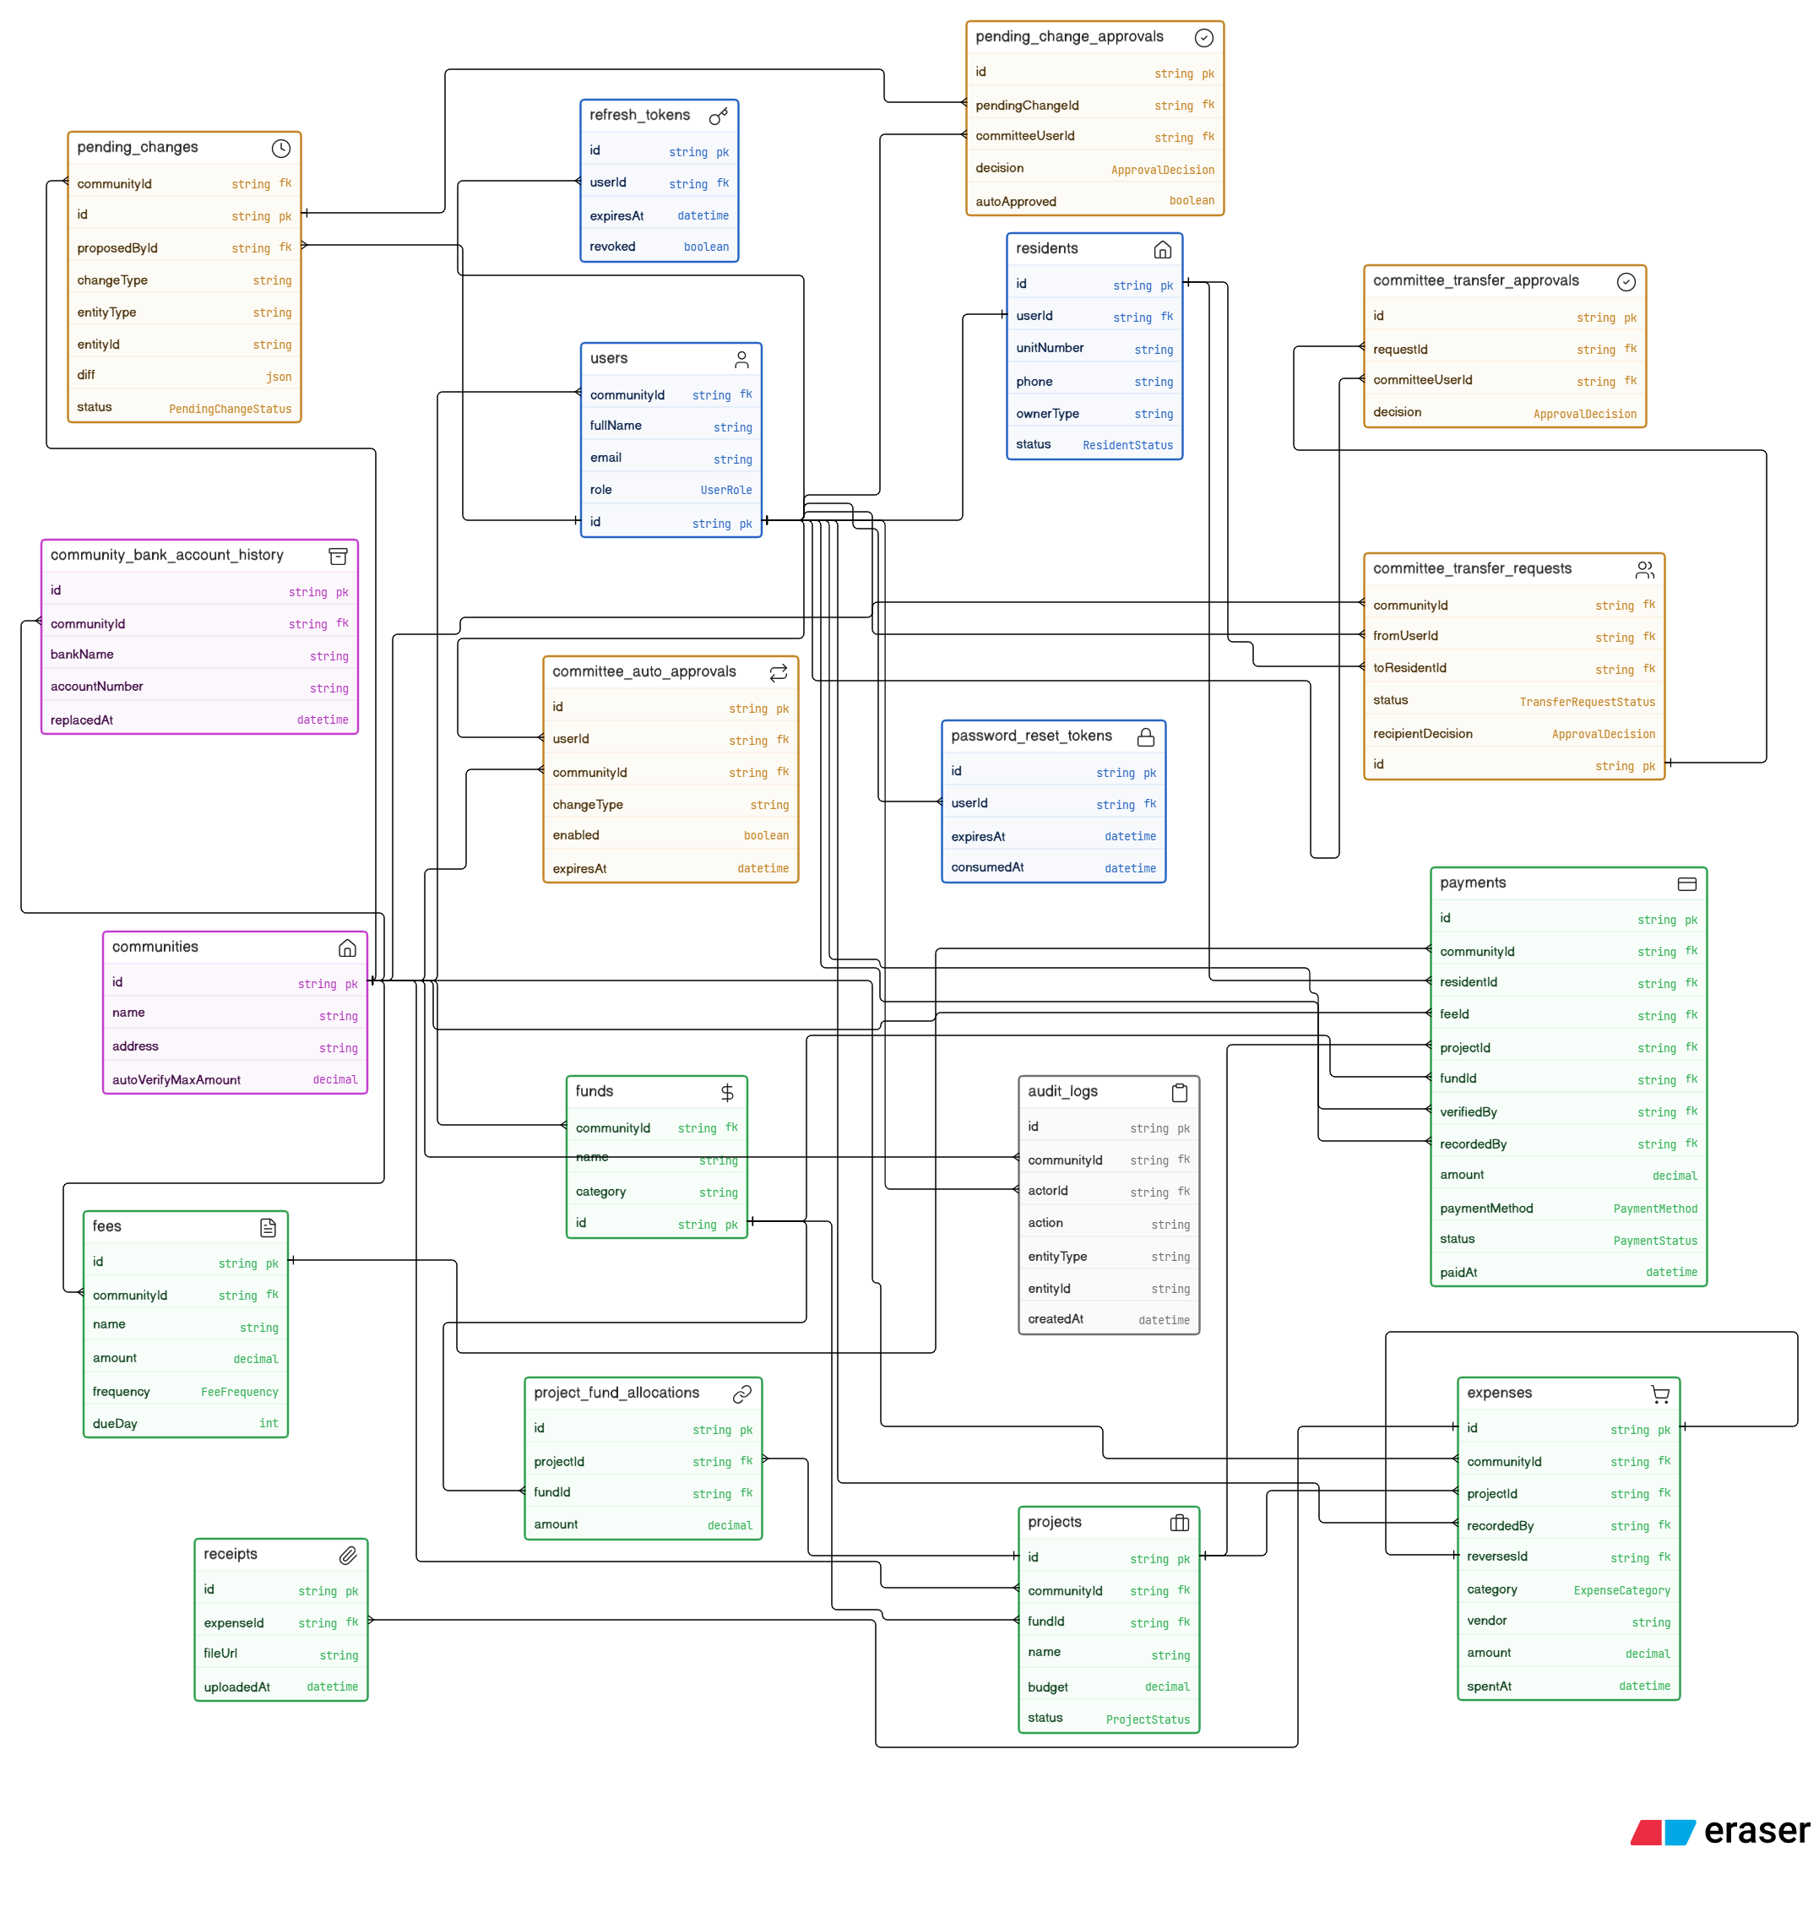
Figure 2: Entity-Relationship Diagram — core Odaa data model
Relationship Reference
The diagram's connector lines can be hard to trace visually at this density — the same relationships are listed here explicitly, grouped by domain, using the same notation as the diagram itself so the relationship type is unambiguous:
- A.id < B.fk one-to-many — one row in A (the “one” side, left) relates to many rows in B (the “many” side, right).
- A.id - B.fk one-to-one — exactly one row in A relates to exactly one row in B.
Tenant root — communities
- communities.id < users.communityId — one community has many users.
- communities.id < fees.communityId — one community has many fee schedules.
- communities.id < funds.communityId — one community has many funds.
- communities.id < projects.communityId — one community has many projects.
- communities.id < payments.communityId — denormalized for fast community-scoped queries.
- communities.id < expenses.communityId — denormalized for fast community-scoped queries.
- communities.id < audit_logs.communityId — every log entry is scoped to a community.
- communities.id < committee_transfer_requests.communityId — seat-transfer requests are scoped to one community.
- communities.id < pending_changes.communityId — sensitive-change proposals are scoped to one community.
- communities.id < community_bank_account_history.communityId — one history of bank-detail snapshots per community.
- communities.id < committee_auto_approvals.communityId — auto-approval rules are scoped to a community.
Identity & access
- users.id - residents.userId — one-to-one; a RESIDENT user has exactly one resident profile.
- users.id < refresh_tokens.userId — a user can have many issued refresh tokens (one per session).
- users.id < password_reset_tokens.userId — a user can have many password-reset tokens over time.
- users.id < audit_logs.actorId — who performed the logged action (one user, many log entries).
- users.id < committee_transfer_requests.fromUserId — the committee member proposing a seat transfer.
- users.id < committee_transfer_approvals.committeeUserId — the committee member casting an approve/reject vote.
- users.id < pending_changes.proposedById — who proposed the sensitive change.
- users.id < pending_change_approvals.committeeUserId — the committee member voting on a pending change.
- users.id < committee_auto_approvals.userId — the committee member who owns the standing auto-approval rule.
- users.id < payments.verifiedBy — the admin who manually verified a payment (nullable).
- users.id < payments.recordedBy — the admin who manually recorded a payment on a resident's behalf (nullable).
- users.id < expenses.recordedBy — the admin who recorded the expense.
- residents.id < payments.residentId — every payment is made by exactly one resident; a resident can have many payments.
- residents.id < committee_transfer_requests.toResidentId — the resident a committee seat is being offered to.
Money & ledger
- fees.id < payments.feeId — one of the three possible payment targets (nullable FK).
- funds.id < payments.fundId — direct-to-fund payments (nullable FK).
- projects.id < payments.projectId — payments made toward a capital project (nullable FK). Exactly one of feeId / fundId / projectId is set per payment.
- funds.id < projects.fundId — a project's primary/default fund (required).
- funds.id < project_fund_allocations.fundId — a fund can supply budget to many projects.
- projects.id < project_fund_allocations.projectId — a project's budget can be split across multiple funds; allocation amounts must sum to the project's budget.
- projects.id < expenses.projectId — expenses optionally attach to a project.
- expenses.id - expenses.reversesId — self-referencing, one-to-one; a reversal row points back at the original expense it corrects (append-only correction pattern).
- expenses.id < receipts.expenseId — an expense can have multiple attached receipts.
Governance & approvals
- committee_transfer_requests.id < committee_transfer_approvals.requestId — each committee member gets one approval row per transfer request.
- pending_changes.id < pending_change_approvals.pendingChangeId — each committee member gets one approval row per pending change.

— 3.3 Notable Modeling Decisions

Payment target is XOR, not polymorphic
A Payment has three nullable foreign keys — feeId, projectId, fundId — and exactly one must be set. This was chosen over a single polymorphic (entityType, entityId) column so that referential integrity and cascade-delete behavior keep working natively through Prisma/Postgres foreign keys, at the cost of the exactly-one-of-three constraint having to be enforced in the application layer (Zod's .refine(), since Postgres CHECK constraints across three nullable columns aren't expressible in the Prisma schema).

Expense correction is append-only, not editable
There is no update endpoint for Expense. A correction is made by creating a new, linked "reversal" row with a negated amount (reversesId points back at the original; isVoided is set on the original). This is covered in detail in §5.2.

Phone login uses a precomputed search key
Resident.phoneSearchKey stores the last 9 digits of the resident's phone number, kept in sync whenever phone is written, and is indexed. Login-by-phone does an indexed equality lookup on this field. The comment in the code notes this replaced an earlier version that pulled every resident with a phone number across the entire platform into Node and scanned them with String#endsWith — a full-table scan on every phone login that would have gotten slower as the resident table grew.

Fund category is now its own column
Fund.category was originally reused off the free-text Fund.description field, which meant a fund could never have its own separate notes. It has since been split into its own column, so category (shown as a badge in the UI) and description (a free-text note on why the fund exists) no longer collide.

A project can be jointly funded across more than one Fund
Project keeps a single required fundId for backward compatibility and default reporting, but the real money breakdown for a project's budget now lives in ProjectFundAllocation, a join table of (project, fund, amount) rows. This lets a capital project draw its budget from more than one fund account (e.g. partly from "Maintenance" and partly from "Emergency Fund") while keeping a clear primary fund for simple views. The allocation amounts must sum to Project.budget, enforced in the application layer rather than the database, since a cross-row Decimal sum isn't a constraint Prisma/Postgres can express directly.

Money is always Decimal, never Float
Every monetary column (amounts on Fee, Payment, Fund, Project, Expense, ProjectFundAllocation) uses Prisma's Decimal type, backed by Postgres numeric, rather than a float/double. Floats can't represent amounts like 19.99 exactly in binary, and summing hundreds of them (a community's full payment history, say) reliably accumulates visible rounding error over time; Decimal avoids that class of bug entirely at the cost of needing a decimal-aware library (rather than plain +) wherever the backend does arithmetic on money.

Residents are deactivated, never deleted
Resident has a status enum (ACTIVE / INACTIVE / MOVED_OUT) plus inactiveReason and inactivatedAt, and there is no delete endpoint for residents — only deactivate/reactivate (see §6.3). A resident who moves out still has a real payment and fee history that the community's financial records depend on; deleting the row would either orphan that history or force cascading deletes through Payment/Fee, either of which breaks the append-only guarantee the whole ledger design depends on.

4. Authentication & Authorization

— 4.1 Authentication Flow
- A JWT access token (short-lived) is returned in the response body and sent by the client as a bearer token on every request.
- A refresh token (7-day) is set as an httpOnly cookie, scoped to /api/v1/auth, and its hash is stored server-side in RefreshToken so it can be revoked.
- POST /auth/refresh rotates the token: the old refresh token is marked revoked and a brand-new access/refresh pair is issued. This limits the blast radius of a leaked refresh token to a single use.
- Cookie SameSite is 'lax' in development (frontend and backend share an origin via Vite's proxy) and 'none' + secure in production, since frontend and backend are expected to run on different hosts in a typical deployment — a cross-site request from the browser's point of view.
- Login accepts either an email address or a phone number in the same identifier field, auto-detected by the presence of "@".
- changePassword requires the caller's current password and revokes every other outstanding refresh token for that user, forcing re-authentication on other sessions.
- Forgot/reset password: POST /auth/forgot-password issues a single-use, short-lived PasswordResetToken (only its hash is stored) and emails a reset link via SMTP (src/utils/email.js); if SMTP isn't configured, the email is logged to the console instead of sent, so local dev works without real mail credentials. POST /auth/reset-password consumes the token and sets a new password. Both endpoints are rate-limited to blunt enumeration/mail-bombing.

— 4.2 Sequence: Login → Refresh
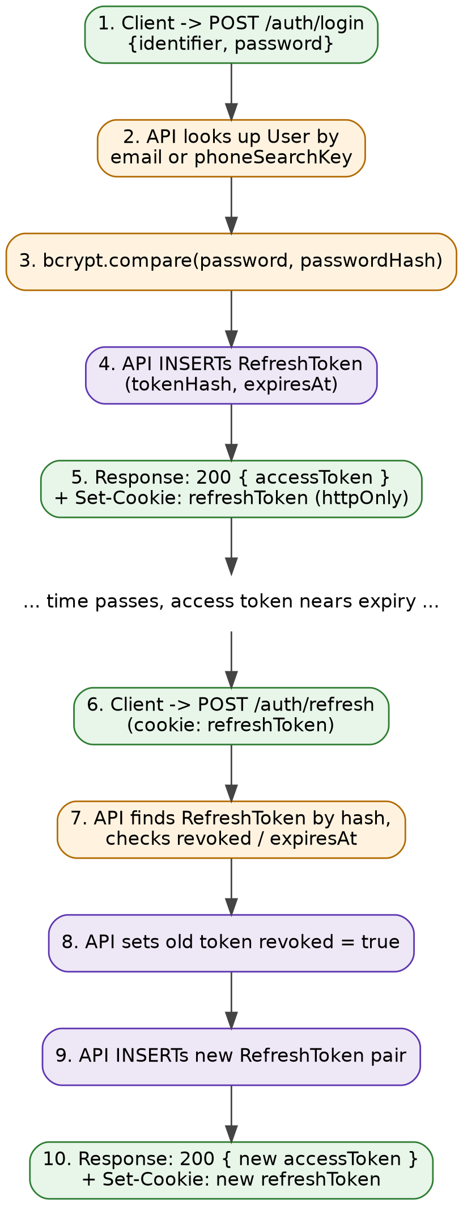
Figure 3: Sequence Diagram — Login and Refresh-Token Rotation Flow

— 4.3 Authorization Model
Authorization is role-based (RBAC) with two roles — ADMIN, RESIDENT — enforced per-route via an authorize(...roles) middleware, layered on top of the tenant scoping described in §2.3. There is no finer-grained permission system (e.g. per-community custom roles); every ADMIN in a community has full committee-member rights over that community.

5. Core Domain Workflows

— 5.1 Bank Payment Self-Verification
Residents can self-verify a bank or mobile-money payment instead of waiting for a committee member to manually confirm it. The resident submits the transaction ID (plus, for some providers, a secondary field — see below), and the backend calls Veritas, a third-party service that reverse-engineers receipt data from CBE, Telebirr, Dashen, Bank of Abyssinia, CBE Birr, and M-Pesa.
- Some providers need more than the transaction ID to disambiguate a match: CBE and Bank of Abyssinia require a reference suffix; CBE Birr requires the payer's phone number in 251XXXXXXXXX format.
- A Veritas 'matched: true' result is treated as strong evidence, not final proof — an additional safeguard layer cross-checks the payer name and amount against what the resident claimed. If the name doesn't match closely, the amount is outside tolerance, the payment is at or above the community's configured autoVerifyMaxAmount, or the provider's response didn't include enough fields to check confidently, the payment is set to PENDING_REVIEW instead of VERIFIED and flagged with human-readable reviewFlags for a committee member to inspect.
- The raw Veritas response is stored (verificationRaw) so a reviewing admin can see exactly what the bank lookup returned, not just a pass/fail summary.
- If no Veritas API key is configured, the service runs in a stub mode so local development still works — this is loudly flagged (boot-time warning, admin-facing banner) rather than silently falling back to always-matches behavior in production.
NOTE Veritas is explicitly documented in the code as an unofficial, single-vendor dependency with no bank-level accountability — a real availability/accuracy risk worth calling out to any reviewer, and the reason the safeguard cross-check exists as a second layer rather than trusting the provider outright.
Two additional resident-facing conveniences sit alongside self-verification: POST /payments/parse-screenshot lets a resident upload a screenshot of their bank/mobile-money confirmation, which is OCR'd (OCR.space) and then passed to a Groq-hosted LLM to classify the raw text into amount, payer name, transaction ID, bank name, and date — purely to prefill the payment form, never trusted for verification itself. DELETE /payments/:id/retract lets a resident withdraw their own still-pending self-verified payment. On the review side, POST /payments/batch-verify lets an admin verify or reject several PENDING_REVIEW payments in one call instead of one at a time.

— 5.2 Append-Only Expense Ledger
Expenses have no destructive update endpoint. A correction is made via a reverse action that creates a new Expense row with a negated amount, linked back to the original via reversesId, while the original is flagged isVoided. Fund and project spend totals sum Expense.amount directly, so a reversal nets out automatically without any special-case exclusion logic elsewhere in the codebase.
A narrow, tightly-scoped hard-delete exception exists: an expense can be deleted outright only within a 15-minute grace window after creation, only by the person who recorded it, only if it has no receipts attached, and only if it has not been reversed and is not itself a reversal. This window is measured from createdAt (when the row was recorded), not spentAt (which can be backdated), specifically so the delete window can't be reopened by editing the expense's date.

— 5.3 Multi-Party Approval Workflows

Committee seat transfer
A committee member (ADMIN) can propose handing their seat to a specific resident. This only takes effect once every other committee member in the community has approved and the chosen resident has separately accepted; a single rejection at either stage kills the request.

Generalized sensitive-change approval (PendingChange)
Any action considered too sensitive for one committee member to apply unilaterally — currently, editing the community's payment bank details — is routed through a generic PendingChange record instead of being applied directly. Every other committee member gets an approval row; one rejection kills it; it applies automatically once everyone has approved, or auto-expires after 24 hours. The diff (what would change) is stored as JSON, so it is both what reviewers see and the literal source of truth applied on final approval. The type of change is a free-text changeType tag rather than an enum, specifically so a new category of sensitive action can be added with a new case in the apply-diff logic and no schema migration. A second changeType now uses the same engine: cancelling a capital project (PROJECT_CANCELLATION) also requires a committee-wide sensitive-change approval, with a mandatory cancelReason recorded once it takes effect, rather than a plain status update any single ADMIN could make.

— 5.4 Audit Log
Every meaningful action — creating, updating, or deleting residents, fees, payments, funds, projects, and expenses; committee-seat transfers — is written to an AuditLog row. Any committee member (ADMIN) can view the full log for their community via GET /audit-logs. There is deliberately no PATCH/PUT/DELETE route for this resource — the log is append-only by omission, not by a soft-delete flag.

— 5.5 Committee Auto-Approval
A committee member can pre-authorize their own future vote on PendingChanges of a specific changeType (CommitteeAutoApproval), so routine low-stakes requests of that type don't need a manual click every time.
- Scope: per (user, changeType) — enabling it for one change type (e.g. PROJECT_BUDGET) says nothing about another (e.g. PROJECT_CANCELLATION).
- Guardrails: it always has a mandatory expiresAt (no permanent/forever option), can optionally be narrowed to only auto-approve proposals from specific trusted co-admins (scopedToUserIds), and enabling it server-side requires acknowledgedAt — proof the member clicked through an explicit accountability warning, checked on the server so a raw API call can't silently skip the confirmation dialog.
- Accountability: an auto-approved vote is still written to the same PendingChangeApproval table as a manual one, just with autoApproved: true, so the audit trail always shows accurately how each vote was cast.
- API: GET /committee-auto-approvals lists the caller's own standing auto-approvals; PUT /committee-auto-approvals creates or updates one.

6. API Reference
Base URL: /api/v1. All endpoints except registration, login, refresh, and logout require an Authorization: Bearer <accessToken> header. Responses follow { success: boolean, data?, message? }. Validation failures return 422 with Zod field-level errors.

— 6.0 Conventions
Every response body follows the same envelope regardless of endpoint: { success: boolean, data?, message?, details? }. A successful GET/POST/PATCH returns success: true with the result in data; an error returns success: false with a human-readable message, and, for validation failures specifically, a details array of { path, message } pairs — one per invalid field — produced directly from the Zod schema's own error output (see validate middleware, §10/11 Security). Every write endpoint validates its body this way before the controller ever runs.
POST /api/v1/auth/register-community
{
"community": { "name": "Sunrise Estates" },
"admin": {
"fullName": "Alice Admin",
"email": "alice@example.com",
"password": "SuperSecret1"
}
}
201 Created
{
"success": true,
"data": {
"community": { "id": "...", "name": "Sunrise Estates" },
"user": {
"id": "...", "fullName": "Alice Admin",
"email": "alice@example.com", "role": "ADMIN"
/* passwordHash is never included */
},
"accessToken": "eyJhbGciOi..."
}
}
# A refresh-token cookie (odaa_refresh_token, httpOnly) is also set
# on the response — it never appears in the JSON body itself.
A validation failure looks the same shape everywhere in the API, regardless of which endpoint or field failed:
422 Unprocessable Entity
{
"success": false,
"message": "Validation failed",
"details": [
{ "path": "body.admin.email", "message": "Invalid email" },
{ "path": "body.admin.password", "message": "String must contain at least 8 character(s)" }
]
}
A duplicate-key or missing-relation error from Prisma is caught centrally by errorHandler and translated into the same envelope with an appropriate status — the caller never sees a raw Prisma/Postgres error shape, just a consistent { success: false, message } regardless of whether the failure originated in validation, business logic, or the database itself:
409 Conflict (duplicate email, Prisma P2002)
{ "success": false, "message": "A record with this email already exists" }
404 Not Found (Prisma P2025)
{ "success": false, "message": "Record not found" }
List endpoints that support pagination (payments, expenses, residents) accept ?page= and ?limit= query params and return a meta object alongside data:
GET /api/v1/payments?page=1&limit=50
{
"success": true,
"data": [ /* up to 50 payment records */ ],
"meta": { "page": 1, "totalPages": 4, "total": 187, "limit": 50 }
}

— 6.1 Auth
Method | Path | Role | Description
POST | /auth/register-community | Public | Creates a new tenant Community plus its first ADMIN user, in a single transaction. This is the SaaS sign-up flow.
POST | /auth/login | Public | Logs in by email or phone (identifier field, auto-detected) + password. Issues an access token and sets the refresh-token cookie.
POST | /auth/refresh | Public (cookie) | Rotates the refresh token and issues a new access/refresh pair.
POST | /auth/logout | Public (cookie) | Revokes the current refresh token and clears the cookie.
GET | /auth/me | Authenticated | Returns the current user with resident/community relations.
PATCH | /auth/change-password | Authenticated | Changes the caller's password; revokes all other active sessions.
POST | /auth/forgot-password | Public | Issues a single-use password-reset token (hash stored server-side) and emails a reset link. Always returns success regardless of whether the email exists, to avoid leaking which emails are registered.
POST | /auth/reset-password | Public | Consumes a valid, unexpired reset token and sets a new password.

— 6.2 Communities
Method | Path | Role | Description
GET | /communities/me/current | ADMIN, RESIDENT | Gets the caller's own community, including bank payment details residents need to pay into.
PATCH | /communities/me/current | ADMIN | Updates the caller's community. Sensitive fields (payment bank details) route through PendingChange rather than applying directly.

— 6.3 Residents
Method | Path | Role | Description
GET | /residents/me | RESIDENT | Gets the caller's own resident profile.
PATCH | /residents/me | RESIDENT | Updates the caller's own resident profile.
POST | /residents | ADMIN | Creates a new resident (and its User account) in the caller's community.
GET | /residents | ADMIN | Lists all residents in the caller's community.
GET | /residents/:id | ADMIN | Gets a specific resident.
GET | /residents/:id/summary | ADMIN | Full profile plus a missingPayments list — every community fee this resident has no verified/pending payment against.
PATCH | /residents/:id | ADMIN | Updates a resident's profile fields.
DELETE | /residents/:id | ADMIN | Removes a resident.
GET | /residents/meta/common-inactive-reasons | ADMIN | Returns a preset list of common deactivation reasons (e.g. “Non-payment of fees”) to populate the deactivate dialog; the committee member can still free-type a custom reason instead.
GET | /residents/:id/export | ADMIN | Exports a resident's payment history as a downloadable file (Excel via ExcelJS).
POST | /residents/:id/deactivate | ADMIN | Marks a resident INACTIVE or MOVED_OUT, recording a reason (preset or free-typed) and inactivatedAt.
POST | /residents/:id/reactivate | ADMIN | Sets a resident back to ACTIVE and clears the inactive reason/timestamp.

— 6.4 Fees
Method | Path | Role | Description
POST | /fees | ADMIN | Creates a fee (name, amount, frequency, optional dueDay).
GET | /fees | ADMIN, RESIDENT | Lists fees for the community.
GET | /fees/:id | ADMIN, RESIDENT | Gets a specific fee.
PATCH | /fees/:id | ADMIN | Updates a fee.
DELETE | /fees/:id | ADMIN | Deletes a fee.

— 6.5 Payments
Method | Path | Role | Description
POST | /payments | ADMIN, RESIDENT | Records a payment against exactly one of feeId, projectId, or fundId.
GET | /payments | ADMIN, RESIDENT | Lists payments (residents see only their own).
POST | /payments/self-verify | RESIDENT | Submits a bank/mobile-money transaction ID for automatic verification (see §5.1).
POST | /payments/parse-screenshot | ADMIN, RESIDENT | OCRs an uploaded payment screenshot and returns a best-guess payer name / transaction ID to help autofill the payment form.
GET | /payments/:id | ADMIN, RESIDENT | Gets a specific payment.
PATCH | /payments/:id/status | ADMIN | Manually sets a payment's status (PENDING / PENDING_REVIEW / VERIFIED / REJECTED).
PATCH | /payments/:id | ADMIN | Edits a manually-recorded payment. Restricted in the controller to payments with recordedBy set — self-verified bank payments stay append-only.
DELETE | /payments/:id | ADMIN | Deletes a manually-recorded payment (same append-only restriction as above).
POST | /payments/:id/receipt | ADMIN | Attaches a receipt photo/PDF to a manually-recorded payment.

— 6.6 Funds
Method | Path | Role | Description
POST | /funds | ADMIN | Creates a fund.
GET | /funds | ADMIN, RESIDENT | Lists funds.
GET | /funds/summaries | ADMIN, RESIDENT | Lists all funds with computed balance summaries in one call.
GET | /funds/:id | ADMIN, RESIDENT | Gets a specific fund.
GET | /funds/:id/summary | ADMIN, RESIDENT | Computed balance: allocated vs. spent across the fund's projects and direct payments.
PATCH | /funds/:id | ADMIN | Updates a fund.
DELETE | /funds/:id | ADMIN | Deletes a fund.

— 6.7 Projects
Method | Path | Role | Description
POST | /projects | ADMIN | Creates a capital project under a fund, with a budget and start date.
GET | /projects | ADMIN, RESIDENT | Lists projects.
GET | /projects/:id | ADMIN, RESIDENT | Gets a specific project.
PATCH | /projects/:id | ADMIN | Updates a project.
POST | /projects/:id/cancel | ADMIN | Cancels a project via the PendingChange approval workflow (see \u00a75.3), recording a mandatory cancelReason once every committee member has approved. There is no direct delete endpoint \u2014 a project can only be cancelled, never removed outright.

— 6.8 Expenses & Receipts
Method | Path | Role | Description
POST | /expenses | ADMIN | Records an expense, optionally against a project.
GET | /expenses | ADMIN, RESIDENT | Lists expenses.
GET | /expenses/:id | ADMIN, RESIDENT | Gets a specific expense.
POST | /expenses/:id/reverse | ADMIN | Reverses an expense (see §5.2). No direct edit endpoint exists.
DELETE | /expenses/:id | ADMIN | Hard-deletes an expense — only within the 15-minute grace window (see §5.2).
GET | /expenses/:expenseId/receipts | ADMIN, RESIDENT | Lists receipts attached to an expense.
POST | /expenses/receipts | ADMIN | Uploads a receipt file for an expense.
DELETE | /receipts/:id | ADMIN | Deletes a receipt.

— 6.9 Committee Transfers
Method | Path | Role | Description
POST | /committee-transfers | ADMIN | Proposes handing the caller's committee seat to a specific resident.
GET | /committee-transfers/mine | ADMIN, RESIDENT | Lists transfer requests/approvals relevant to the caller.
PATCH | /committee-transfers/:id/committee-response | ADMIN | Records a committee member's approve/reject decision.
PATCH | /committee-transfers/:id/recipient-response | ADMIN, RESIDENT | Records the chosen recipient's accept/reject decision.
DELETE | /committee-transfers/:id | ADMIN | Cancels a transfer request the caller initiated.

— 6.10 Pending Changes
Method | Path | Role | Description
GET | /pending-changes/mine | ADMIN | Lists sensitive-change proposals the caller needs to review or initiated.
PATCH | /pending-changes/:id/respond | ADMIN | Approves or rejects a pending change.
DELETE | /pending-changes/:id | ADMIN | Cancels a pending change the caller proposed.
NOTE There is no generic POST here by design — a pending change is always created from the domain controller that owns the entity being changed (e.g. updating community bank details), which knows the correct changeType/entityId/diff to record. This router only covers the shared review lifecycle.

— 6.11 Dashboard & Reports
Method | Path | Role | Description
GET | /dashboard/admin | ADMIN | Committee-facing summary: collections, fund balances, recent activity.
GET | /dashboard/resident | RESIDENT | Resident-facing summary: own balance, payment history, outstanding fees.
GET | /reports/collections | ADMIN | Collections report (fee payments over time).
GET | /reports/expenses | ADMIN | Expense report.
GET | /reports/summary | ADMIN | Overall financial summary report.

— 6.12 Audit Log
Method | Path | Role | Description
GET | /audit-logs | ADMIN | Lists the full audit trail for the caller's community. Read-only by design — no write routes exist.

— 6.13 Committee Auto-Approval
Method | Path | Role | Description
GET | /committee-auto-approvals | ADMIN | Lists the caller's own standing auto-approval rules.
PUT | /committee-auto-approvals | ADMIN | Creates or updates an auto-approval rule for one changeType. Requires an explicit expiresAt and a server-checked acknowledgedAt confirming the member accepted the accountability warning; optionally scoped to specific co-admins via scopedToUserIds.

7. Known Limitations & Design Tradeoffs
These are documented, deliberate tradeoffs rather than defects — called out here so a reviewer sees the reasoning instead of independently rediscovering the gap.
Area | Tradeoff
Tenant isolation | Enforced entirely in application code (tenantScope + per-query filters), not at the database level (no Postgres RLS, no per-tenant schema). Correct today, but every new query must remember to filter by community — there is no structural backstop if one doesn't.
Bank verification | Depends on Veritas, an unofficial single-vendor service with no bank-level accountability. Mitigated with a name/amount safeguard layer and an explicit stub-mode warning, but it is still a third-party availability and accuracy risk.
Receipt/file storage | Previously written to local disk on the backend container, which would not have survived a multi-instance or ephemeral-filesystem deployment. Production now uploads to Supabase Storage (S3-compatible object storage) instead, so this specific risk is resolved; local disk is still used as a fallback for local development without Supabase credentials configured.
Authorization granularity | Role-based with exactly three roles; no per-community custom roles or finer permission scoping — every ADMIN has full committee rights.
Expense hard-delete window | The 15-minute/no-receipts/own-record grace window is a narrow escape hatch for genuine data-entry mistakes, but it is still a real exception to "expenses are append-only" worth being explicit about, not silently relying on.
No CI pipeline | There is no automated pipeline (e.g. GitHub Actions) running the backend test suite on push/PR — tests exist (§10/9) and pass locally, but nothing currently blocks a broken commit from reaching main or being deployed.
No API contract file | There is no OpenAPI/Swagger spec; §6 of this document is hand-written documentation of the routes, kept in sync manually rather than generated from (or validated against) the code. It can drift from the actual implementation if a route changes and the doc isn't updated alongside it.
Health check is shallow | GET /health confirms the Node process is up, not that it can reach the database — a backend that has lost its database connection would still report healthy to Render's monitoring.

8. Deployment
The project ships with a docker-compose.yml defining three services (postgres, backend, frontend) plus named volumes for Postgres data and uploaded receipts, for local development. A single docker compose up --build brings up the full stack; migrations and seeding are run as one-off commands against the backend container afterward. The live deployment, however, runs on Render: the backend as a Node web service and the frontend as a static site, both built from the same repository, with a Supabase-hosted PostgreSQL database (DATABASE_URL) and Supabase Storage for uploaded receipts/screenshots rather than the container's local disk. Beyond the database and JWT secrets, production configuration adds: CORS_ORIGIN (the deployed frontend's URL); SMTP_HOST/SMTP_PORT/SMTP_USER/SMTP_PASS for the forgot-password email (falls back to console logging if unset, so local dev doesn't need real mail credentials); GROQ_API_KEY for screenshot-autofill text classification; OCRSPACE_API_KEY for the OCR step ahead of it; and VERITAS_API_KEY for bank-transfer verification (falls back to stub mode with an on-screen warning if unset). The frontend's VITE_API_URL is set at build time to point at the deployed backend.

— 8.1 Database Migrations & Seeding
Schema changes go through Prisma Migrate rather than manual SQL. A developer changes schema.prisma, runs npx prisma migrate dev --name <description> locally to generate a timestamped, checked-in SQL migration file and apply it to their local database, and commits that migration file alongside the code change. In production, npx prisma migrate deploy applies any pending migrations in order and does not generate new ones or prompt for input, making it safe to run non-interactively as part of a deploy. The seed script (npm run seed) is separate from migrations entirely — it populates demo data (a sample community, admin, resident, fees, payments) and is meant for local development and the tests/README.md test-database setup, never run against the real production database.

— 8.2 Environment Variables
The backend fails loudly at startup rather than silently misbehaving if a required variable is missing in production (see the CORS_ORIGIN check in §10.1/11.1). The full set actually read by the backend:
- DATABASE_URL — Postgres connection string (Supabase in production, local Postgres/Docker in development). Required.
- JWT access/refresh secrets — sign and verify the short-lived access token and the httpOnly refresh token. Required.
- CORS_ORIGIN — comma-separated list of allowed frontend origin(s). Required in production; defaults to http://localhost:5173 in development with a console warning.
- NODE_ENV — gates several behaviors: trust proxy, cookie sameSite/secure flags, rate-limit thresholds, and whether stack traces are included in error responses.
- SMTP_HOST / SMTP_PORT / SMTP_USER / SMTP_PASS — for the forgot-password email. If unset, the email is logged to the console instead of sent, so local development doesn't need real mail credentials.
- FRONTEND_URL — the deployed frontend's base URL, used to build the password-reset link sent by email.
- GROQ_API_KEY — LLM classification step of the payment-screenshot autofill feature.
- OCRSPACE_API_KEY — OCR step ahead of the Groq classification, for the same feature.
- VERITAS_API_KEY — bank-transfer verification provider. If unset, the backend runs in stub mode with an on-screen warning rather than failing self-verification outright (see §7 Known Limitations).
- Supabase Storage credentials — used for uploaded receipts/screenshots in production; falls back to local disk if not configured, for local development.

— 8.3 Health Checks & Observability
GET /health returns a plain { success: true, status: "ok", time }, used by Render (and any uptime monitor) to determine whether the backend process is alive and accepting requests — it does not currently check database connectivity, so a backend that's up but has lost its database connection would still report healthy. Request logging uses morgan, in the verbose 'combined' Apache-style format in production and the terser 'dev' format locally; all errors are logged server-side via console.error on every request regardless of environment (see §10/11 errorHandler), though there is currently no external log aggregation or alerting wired up beyond whatever Render's own log viewer provides.

9. Frontend Structure
The frontend is a Vite + React 18 single-page app (odaa-frontend/), styled with Tailwind, talking to the backend through a single Axios client. It has no server-side rendering and no separate mobile app — one responsive web app serves both roles.

— 9.1 Directory Layout
- src/pages/admin/ and src/pages/resident/ — each role gets its own parallel set of pages (Dashboard, Payments, Funds, Projects, Expenses, Reports, plus admin-only Residents, Fees, Receipts, Audit Log), rather than one page branching internally on role. src/pages/shared/Profile.jsx and the top-level Login/ForgotPassword/ResetPassword pages are the only ones used by both roles.
- src/layouts/AppLayout.jsx — the shared shell (nav, header, role-aware menu) that every authenticated page renders inside.
- src/context/ — three React Context providers: AuthContext (session/user state), DataContext (fetches and caches the community's residents/fees/payments/funds/projects/expenses/receipts/pending-changes), and ThemeContext (light/dark mode).
- src/lib/api.js — the single configured Axios instance every page goes through, plus a named endpoints() map so route strings live in one place instead of being hand-typed per call site.
- src/lib/adapters.js — converts between the backend's API shape and the shape the UI components expect in each direction (e.g. residentToUI / residentToCreateAPI), so a backend field rename only has to be fixed in one file rather than in every page that touches residents.
- src/components/ui.jsx — the shared low-level UI primitives (buttons, inputs, the toast notifier) reused across every page instead of each page rolling its own.

— 9.2 Routing
Routing is handled by react-router-dom in App.jsx with two route trees mounted under /admin and /resident, each wrapped in a Protected component that checks the logged-in user's role before rendering. An admin is always also treated as a resident of their own community, so admins can freely view the resident-side pages (with a menu to switch views); a resident can never cross into /admin. Anyone not logged in is redirected to /login; anyone already logged in visiting /login, /forgot-password, or /reset-password is redirected straight to their dashboard instead.

— 9.3 Data Fetching & State
- DataContext loads everything for the logged-in user's community once per login (and on manual refresh) rather than each page fetching independently, so different pages never show inconsistent snapshots of the same underlying data.
- List endpoints (payments, expenses) are paginated server-side; DataContext pages through them in bounded chunks of 500 to load the full set, but does an initial fast first-page fetch first so the UI has something to render immediately rather than blocking on the full paginated load.
- Session persistence: the access token and a lightweight copy of the logged-in user are kept in localStorage so a page refresh doesn't force a re-login; the actual refresh token itself is never touched by JavaScript — it lives only in the httpOnly cookie set by the backend (see §10/11 Security).
- api.js transparently retries a request once after refreshing an expired access token (via /auth/refresh), so a session silently continues working across the 15-minute access-token lifetime instead of surfacing a spurious “Authentication required” error to the user.

— 9.4 Notable UI-Layer Decisions
- Client-side export/reporting (jspdf, jspdf-autotable, xlsx, html2canvas) runs entirely in the browser — PDF and Excel exports are generated on the user's own machine from already-loaded data, not requested from the backend.
- recharts renders the dashboard's charts; lucide-react supplies icons throughout.
- In production the built static bundle is served by nginx (odaa-frontend/nginx.conf) inside its own Docker image (odaa-frontend/Dockerfile), deployed to Render as a separate service from the backend (see §8 Deployment).

10. Testing
The backend has a real Jest + Supertest integration test suite in odaa-backend/tests/, which fires actual HTTP requests at the Express app (src/app.js) in-memory, against a separate test database that gets truncated before every single test so ordering and leftover state can never affect another test.

— 10.1 What's Covered Today
Coverage is currently focused on auth.test.js: community registration + first-admin creation, duplicate-email rejection, login, and the refresh-token cookie (odaa_refresh_token) being set correctly. The password hash is explicitly asserted to never be returned in an API response and to never be stored in plaintext — the kind of regression that's easy to reintroduce silently without a test pinning it down.

— 10.2 Test Infrastructure
- testDb.js exposes resetDb() (truncates every table) and disconnectDb(), used in beforeEach/afterAll so tests are isolated and Jest exits cleanly instead of hanging on an open Prisma connection.
- factories.js provides reusable setup helpers (e.g. createCommunityWithAdmin) so each test file doesn't hand-roll its own fixture data.
- Tests run against their own database (.env.test, deliberately a separate Supabase project or local DB — never the real one) via npx dotenv -e .env.test -- npx prisma migrate deploy, then npm test runs Jest serially (--runInBand) so tests sharing one truncatable database don't race each other.

— 10.3 Known Gaps
The suite does not yet cover residents, fees, payments (notably the bank-verification stub path), or the tenantScope / authorize middleware directly — i.e. there's no automated test today asserting a RESIDENT is blocked from an admin-only route, or that a user from Community A can never see Community B's data. Both are called out as the highest-value next tests in the project's own tests/README.md, since they're the two properties the whole multi-tenant security model depends on.

11. Security
Security is enforced in layers across the request lifecycle rather than in one place. This section pulls together protections that are each mentioned individually elsewhere in this document (§4 Authentication, §5 workflows, §7 Known Limitations) into one consolidated reference, plus a few app-level protections not covered anywhere else.

— 11.1 Transport & HTTP-Level
- helmet() sets a standard set of protective HTTP response headers (e.g. disabling MIME-sniffing, restricting framing) on every response; x-powered-by is explicitly disabled so the server doesn't advertise it's running Express.
- CORS is allow-listed, not wildcarded: CORS_ORIGIN must be explicitly set to the real frontend URL(s). This is a deliberate hard requirement in production — the server refuses to boot with a wildcard fallback, because a wildcard origin is fundamentally incompatible with sending the httpOnly refresh-token cookie (credentials: true), and would otherwise fail silently rather than loudly.
- Express sits behind Render's reverse proxy in production, with trust proxy set to trust exactly one hop — enough for rate limiting to correctly identify the real client IP from X-Forwarded-For, without trusting an open-ended chain of proxies.
- JSON body size is capped at 2mb, limiting the blast radius of oversized-payload abuse.

— 11.2 Rate Limiting
- A general limiter applies to all of /api: 1,500 requests per 15 minutes per client in production (5,000 in development). This is intentionally generous — a single dashboard load can fan out into a dozen-plus parallel requests, and the frontend polls every 60 seconds, so a naive default limit was tripping on ordinary use, not abuse.
- Auth routes (login, register, forgot-password, reset-password) carry their own stricter, separate rate limit on top of the general one, to blunt credential-stuffing and password-reset-email-bombing specifically.

— 11.3 Authentication & Session Security
- Passwords are hashed (never stored or returned in plaintext) — enforced by an actual test assertion (see §9.1), not just a stated intention.
- Short-lived JWT access tokens plus a separate, longer-lived refresh token issued as an httpOnly cookie (odaa_refresh_token), so the access token that travels in every request header can't be read by client-side JavaScript if the frontend were ever compromised by an XSS bug.
- changePassword revokes every other outstanding refresh token for that user, and PasswordResetToken (like RefreshToken) stores only a hash of the token server-side — a database dump alone can't be used to forge a valid reset link.
- /auth/forgot-password always returns the same success response whether or not the email exists, to avoid leaking which emails are registered to an attacker probing the endpoint.

— 11.4 Authorization & Tenant Isolation
- Every authenticated route is scoped through tenantScope middleware plus per-query filtering by community — the honest tradeoff (documented in §7) is that this is enforced in application code rather than at the database level (no Postgres row-level security), so it depends on every query remembering to filter correctly rather than a structural backstop.
- Role checks (authorize('ADMIN'), etc.) sit in front of route handlers as middleware, not scattered inline checks inside controller logic, so a route's access requirements are visible at a glance from routes/*.js.

— 11.5 Input Validation
Every write endpoint validates its request body against a Zod schema (via a shared validate middleware) before it reaches controller logic, rejecting malformed input — wrong types, missing required fields, out-of-range values — with a 4xx response before it can cause a bug or bad data further downstream.

— 11.6 Data Integrity Safeguards
- Financial history (payments, expenses) is append-only by convention rather than allowing edits/deletes, so the audit trail can't be silently rewritten (see §5.2, §5.4).
- Sensitive changes (project cancellation, certain committee actions) require multi-member committee approval via the PendingChange workflow rather than any single ADMIN acting unilaterally (§5.3).
- Bank-transfer self-verification is cross-checked against Veritas plus a name/amount safeguard layer, rather than trusting a resident's self-reported transaction ID outright (§7).

12. Product Vision & Multi-Tenant Roadmap
The current build (Sections 1–8) implements a single, hard-coded use case: community/HOA management with fixed "resident" and "committee" roles. This section documents where the product is headed — a general-purpose, multi-tenant SaaS platform that any organization can configure for its own membership-management needs, of which community management is just the first template.

— 12.1 Vision Summary
Instead of one fixed system, the platform becomes a configurable engine. A prospective customer ("tenant") visits a public landing page, completes an onboarding wizard describing what they want to manage and what to call the people involved, and receives a unique URL for their own isolated instance. A community association might configure it exactly as today (residents / committee); a company could configure the same engine to manage employee payments and reimbursements; a club could use it for member dues and event votes. The underlying data model, workflows, and UI stay the same — only the labels, enabled modules, and branding change per tenant.

— 12.2 Onboarding & Tenant Provisioning
A new customer completes a guided, multi-step wizard on the public landing page before any account exists. Suggested question categories to cover in the wizard, beyond the three already specified (use case, terminology, expected user count):
- Use-case template — community/HOA, corporate/payroll-style, club/membership, or custom — selecting one pre-fills sensible defaults for the remaining steps.
- Terminology mapping — not just the two headline roles (e.g. "residents"/"committee"), but every role name used in the system, including any sub-groups.
- Feature toggles — which modules are active for this tenant (voting, messaging, bulk import, payments), since not every tenant needs every module.
- Branding — logo, primary color, and display name shown on the tenant's portal.
- Billing/plan tier — if pricing varies by user count or enabled feature set.
- Initial admin account — the first committee-equivalent user, created during onboarding so someone can log in immediately once provisioning finishes.
- Notification preferences — default channel for system emails (password resets, vote alerts, import confirmations).
On completion, the system provisions a unique, isolated URL for the tenant to log in and invite their users. The exact URL scheme (subdomain vs. path-based) is an open decision — see 9.3.
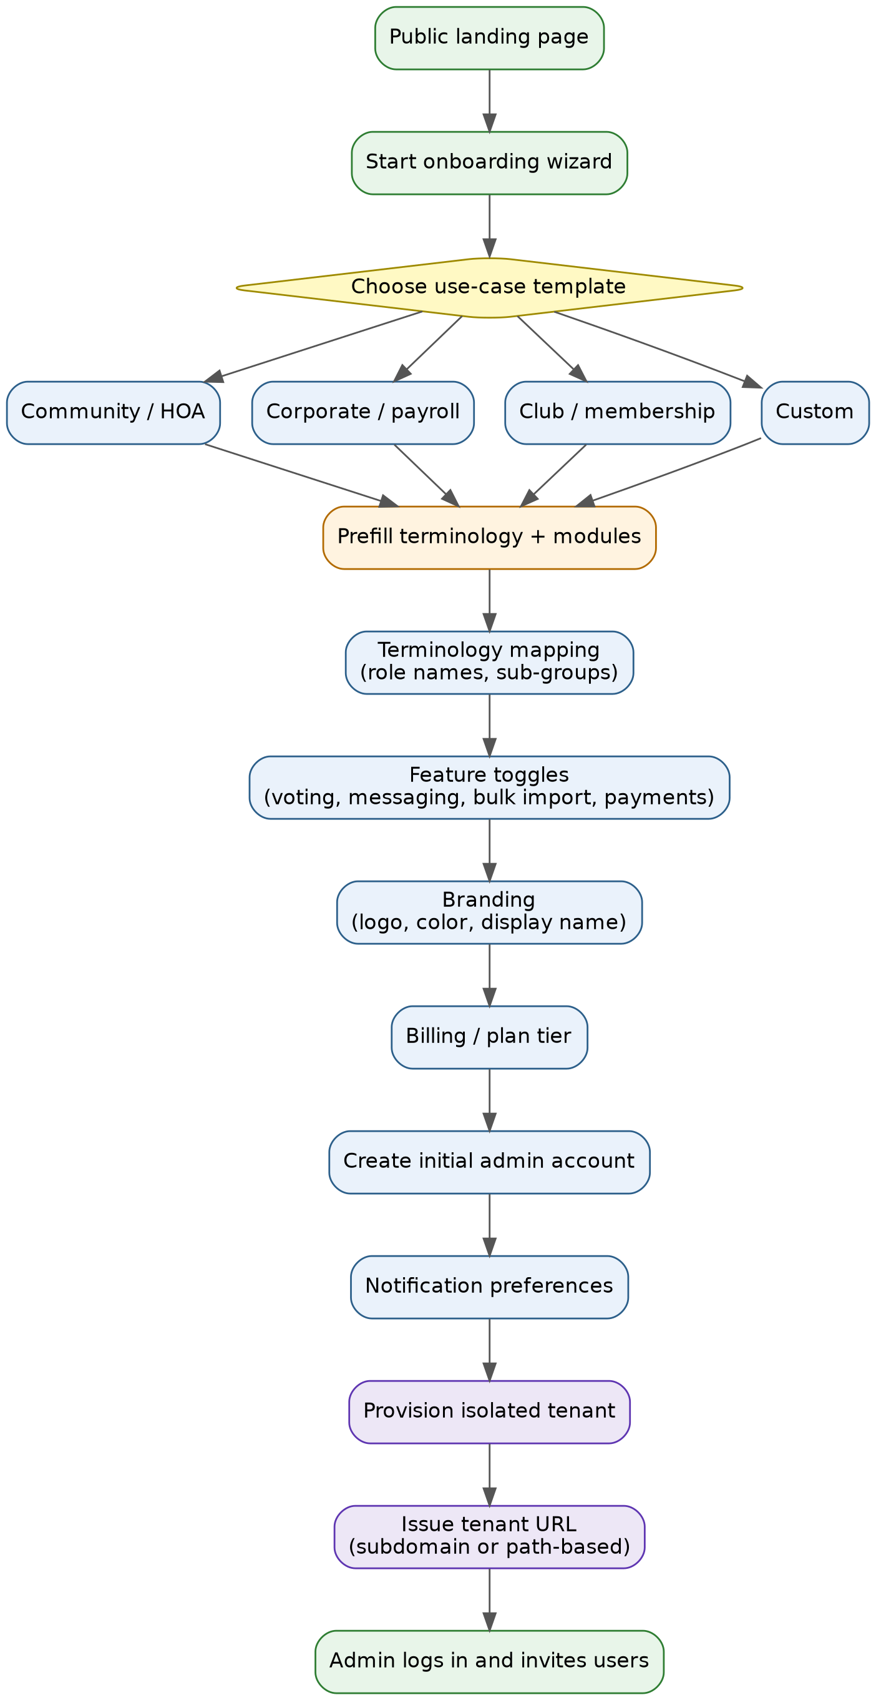
Figure 4: Tenant Onboarding & Provisioning Flow

— 12.3 Open Decision: Tenant URL Scheme
Working assumption: subdomain-based tenant URLs (e.g. greenvalley.yourapp.com), for cleaner tenant isolation, easier per-tenant branding/theming, and no path-collision risk as more routes are added. This is a proposal, not a locked-in decision.
Option | Tradeoff
Subdomain (tenant.yourapp.com) | Cleaner isolation and branding; requires wildcard DNS + wildcard SSL certificate management.
Path-based (yourapp.com/tenant) | Simpler SSL/DNS (single certificate, no wildcard needed); more risk of route collisions and slightly weaker perceived tenant isolation.

— 12.4 Planned Feature Modules

12.4.1 Voting System
Committees (or the tenant-specific equivalent role) can propose initiatives. Each proposal is live for a defined voting window, during which eligible members cast votes; the outcome (proceed / does not proceed) is determined automatically once the window closes.
- Open questions to resolve during design: who is eligible to vote (all members vs. a subset), whether votes are anonymous, what quorum or majority threshold applies, and whether results are visible in real time or only after the window closes.

12.4.2 Messaging
Committees can create multiple groups and mass-add members using filters (e.g. by building, unit, or custom tag), with full chat support including audio, document, and photo sharing.
- Open questions: message retention/history limits, file size caps and storage backend (see Section 7's existing local-disk-storage tradeoff, which this would stress further), read receipts, and moderation/reporting tools.

12.4.3 Bulk Member Import
Committees can download a system-generated Excel template, fill it with their member data, and re-import it. The system automatically creates an account for each row and emails each new user their password.
- Open questions: template validation rules (required columns, duplicate detection), how import errors on individual rows are surfaced without failing the whole batch, and whether passwords are system-generated and forced to reset on first login (recommended over emailing a static password) or securely auto-generated and delivered as a set-up link instead.

12.4.4 Native App Version
A native mobile app (iOS and Android) is planned alongside the web app, backed by the same REST API described in Section 6, so residents and committee members can pay dues, review balances, and approve pending changes from their phones. Push notifications would cover payment confirmations, pending-change approvals awaiting the user's response, and committee-transfer requests.
- Open questions: whether the app is built cross-platform (e.g. React Native, reusing frontend logic) or native per platform; how app releases are versioned against backend API changes so old app versions keep working after a backend deploy; and whether app-only features (push notifications, camera-based receipt/screenshot capture) require new backend endpoints beyond what Section 6 already documents.

12.4.5 Recurring Fee Automation & Late-Fee Rules
Instead of an ADMIN manually creating each fee cycle, committees configure a recurring fee schedule once (amount, frequency, due day) and CFMS generates the corresponding Fee/Payment records automatically each cycle, with reminders sent to residents ahead of the due date and an optional configurable late fee applied automatically once a payment is overdue.
- Open questions: how late-fee rules are configured (flat amount vs. percentage, grace period length, compounding vs. one-time), whether reminders go out via the notification channel from §9.2, and how a resident disputing a late fee routes into the existing PendingChange or a new lightweight dispute flow.

12.4.6 Meeting Scheduling & Minutes
Committees can schedule meetings (regular or ad-hoc), notify members automatically, and attach or record minutes afterward, giving the platform a natural place to log the discussion and outcome behind a committee decision, including any items later formalized through the Voting System (§9.4.1) or a PendingChange (§5.3).
- Open questions: whether minutes are free-text or structured (agenda items, attendance, decisions taken), whether meetings can be linked to specific votes or pending changes they resulted in, and whether residents can view minutes by default or only when a committee explicitly publishes them.

12.4.7 Two-Factor Authentication for Admin Actions
Given how much of §4.3's authorization model rests on ADMIN accounts (bank details, fee amounts, committee transfers), a compromised or careless ADMIN credential is a disproportionately high-value target compared to a RESIDENT one. Two-factor authentication would be required for ADMIN accounts, at minimum for sensitive actions (bank detail changes, committee-seat transfers, PendingChange approvals) even if not enforced on every login.
- Open questions: TOTP app vs. SMS vs. email-based codes (SMS/email are weaker but lower-friction for less technical committee members), whether 2FA is mandatory at signup or opt-in with a nag, and how account recovery works if an ADMIN loses their second factor without locking them out of their own community.

— 12.5 Architectural Implications
Moving from single-tenant to multi-tenant SaaS touches nearly every layer described in Sections 2–8. Key implications to track as design work continues:
- Tenant isolation (Section 7): with many tenants instead of one deployment, application-level-only scoping becomes a higher-stakes tradeoff. Revisit whether per-tenant schemas or row-level security are warranted before general availability.
- Data model (Section 3): role names, group labels, and enabled modules become per-tenant configuration rather than fixed schema — likely a new "tenant configuration" table/entity.
- Auth (Section 4): login and password-reset flows need to resolve which tenant a user belongs to, likely via the tenant's unique URL/subdomain.
- File storage (Section 7): local disk storage will need to move to shared object storage (e.g. S3-compatible) sooner, given messaging attachments and bulk-import templates add to the receipt-storage load already flagged as a limitation.
- Deployment (Section 8): provisioning a new tenant should be an automated, self-service step, not a manual deployment action.
- Client surfaces (Section 4, §9.4.4): the native app version planned alongside multi-tenancy work must stay in sync with the web client on auth and role handling — the current two-role model (ADMIN, RESIDENT) should be the baseline both clients build against going forward, including through any future role or permission changes.

— 12.6 Status
Everything in this section is planned, not built. The current implementation (Sections 1–8) represents only the initial, single-tenant community-management slice. This roadmap will be expanded as design decisions are finalized — additional modules beyond voting, messaging, and bulk import are expected.

